ADVANCE SOCIAL SCIENCE ARCHIVE JOURNAL
1792
Available Online: https://assajournal.com
Print ISSN: 3006-2497 Online ISSN: 3006-2500
Hybrid Radiomic–Deep Feature Fusion for Pediatric Brain Tumor MRI Analysis
Faisal Ashraf, Muhammad Usama Riaz

Abstract — Pediatric brain tumors are severe and may be life-threatening diseases in children and the precise analysis of magnetic resonance imaging (MRI) is the key to proper diagnosis, treatment planning and assessing prognosis. Nevertheless, these tumors are highly variable in terms of shape, size and patterns of intensity in different patients so that automated segmentation and classification is difficult. This challenge is further complicated by the fact that pediatric MRI data are not readily available which can decrease the resilience and generalization capacity of deep learning models. Even though convolutional neural networks (CNNs) have demonstrated high performance in the analysis of brain tumors, their main justification is based on the automatically obtained representations that might not be interpretable and stable under a small-data investigation. To overcome these shortcomings, this paper has developed a hybrid radiomic-deep feature fusion model to examine pediatric brain tumor MRI data based on the BraTS-PED 2024 dataset. The proposed method uses 3D U-Net model to perform multi-class tumor segmentation, and then handcrafted radiomic features are extracted on the segmented tumor regions, and deep features are ex- tracted on a CNN classifier. The complementary feature representations are combined to enhance the performance of classification. The experiment findings show that edema (ED), non-enhancing tumor (NET), and enhancing tumor (ET) areas have Dice similarity coefficients of 0.8509, 0.7182 and 0.7058, respectively, with the background segmenta- tion having a coefficient of 0.85. To classify tumors, the deep learning-based model gave a 97.00 percent valida- tion accuracy, whereas a radiomics-based Random Forest model gave a 98.0 percent accuracy. The results have shown, however, that the combination of radiomic and deep features offers free information, increasing the strength, explanatory power, and general validity in the segmentation and categorization of pediatric brain tumors MRI.
Keywords: Pediatric brain tumor, MRI, Radiomics, Deep learning, Feature fusion, 3D U-Net, Tumor segmenta- tion, Tumor classification, Hybrid model, Machine learning

- Introduction
B
RAIN tumors are seriouos health problems in neuro- oncology, because it is the most frequent solid ma- lignancy identified in children and adults and leads to el- evated mortality with the 5-year survival of approximately 36% condition [1]. Such tumors are highly heterogenous and making them quite hard to diagnose [2]. The primary imaging methodology in the evaluation of the brain tumor is Magnetic Resonance Imaging (MRI) due to the high soft-tissue contrast and the multi-parametric characteristics of the technique [3]. Recent developments in the field of deep learning (DL) have transformed the medical imaging sector by providing

automated, high-accuracy tumor segmentation and classifica- tion capabilities [4]. The latest breakthroughs in the sphere of deep learning (DL) have radically redesigned the medical imaging industry and empowered it to perform automated, high-precision tumor segmentation and classification tasks. The convolutional neural network (CNNs) and their derivatives involve objective and reproducible measurements that are essential in making clinical decisions [4]. Modern DL sys- tems, such as multiscale CNNs, 2D/3D ensembles, attention- based networks, and so on, have delivered excellent results in tumor subregion delineation. As an illustration, when various volumetric CNNs fused by majority votes under fusion, the accuracy of segmentation increased by a significant amount through reducing model biasness [5]. Such strategies are the existing standards of automated brain tumor.
Simultaneously, radiomics have turned out to be an ef- fective instrument of evaluating imaging tumor phenotypes quantitatively. Radiomic analysis identifies high-dimensional quantitative datasets of MRI e.g., shape, texture and inten- sities statistics, indicating the underlying histology, genetic mutations and patient prognosis [6], [7]. Combining radiomic feature and DL representations have resulted in hybrid frame- works that combine both learned and handcrafted features. As an example, the radiomic features, which are generated based on segmented glioma, have been used together with deep networks to predict survival and tumor subtype and have been shown to outperform single-modality models in predictive power [7], [8].
Pediatric brain tumors deserve particular attention because they are the major cause of mortality due to cancer in children [8]. Pediatric neuro-oncology DL research has traditionally been underserved by adult research because of small data sets, greater heterogeneity, and unique tumor biology [9], [10]. The use of conventional radiological evaluation typically performs at a moderate sensitivity regarding the classification of tumors in pediatrics, which is why human-assisted decision making using AI is needed, as is the case of AI-assisted computerized domain assessment, as evidenced in this paper and other scholarly sources [10]. Recent pediatric-specific DL models with age-specific MRI characteristics have high accuracy at distinguishing typical tumor types, indicating the viability of customized hybrid DL-radiomics models [11].
This paper intends to suggest a hybrid radiomics/deep fea- ture fusion model of brain tumor MRI analysis in children. Our solution will utilize a combination of handcrafted radiomic features with learned representations to enhance the accuracy of segmentation and classification, and offer more interpretable

1793

biomarkers to involve clinical decisions, which currently is a limitation of traditional and single-modality applications.

- Related Work
The technique of automated brain tumor segmentation and classification in magnetic resonance imaging (MRI), has been a research topic of considerable activity due to the clinical im- perative to obtain both reproducible and accurate segmentation and classification of tumor subregions. Multiple deep learning techniques have been suggested to perform segmentation with multiscale convolutional neural networks and conditional ran- dom fields being superior in cancer boundary demarcations [1]. Comprehensive literature reviews give an overview of the accelerated development of deep learning models to analyze brain tumors, focus on convolutional networks, ensembles, and attention models as the most popular in recent studies [2], [3], [5], [17], [23] . Self-configuring models like nnU-Net have shown high performance on various biomedical segmentation metrics without significant hyperparameter optimization [6] and recent experimentation on foundation models and seg- mentation adaptation continues to challenge generalization and robustness limits [21], [22].
Beyond segmentation, deep networks have also been trained in diagnosis and classification with high accuracy in classify- ing tumor types based on direct MRI scans [4], [16]. The use of child-specific classification studies indicates that the additional use of clinical characteristics like age can result in better performance and that an appropriate model design in children cohorts is important [14], [19]. Regardless of these improvements, deep learning models are likely to be sensitive to large volumes of labelled data, and unlearned features, which may restrict interpretability and generalization, especially in pediatric data when the sample size is small and the heterogeneity of tumors is high [9], [12], [18].
Similar to deep learning, radiomics has become an influen- tial tool to extract handcrafted quantitative features character- izing tumor shape, texture, and intensity patterns that provide biologically interpretable features that are correlated with histology and clinical outcomes [7], [8], [11], [13]. The body of systematic reviews in the pediatric neuro-oncological field demonstrates how radiomics and deep learning can be used to identify a novel way of characterizing tumor subregions and predicting treatment response, albeit typically in isolation [7], [8], [11]. Integrated radiomic and deep feature systems have also been studied in the context of adult glioma and other brain tumors, which have shown better predictive accuracy with single-modality models than with handcrafted ones [10], [15], [20]. These hybrid approaches combine the advantages of information in the two domains of features, enhancing strength and extrapolation.
Nonetheless, majority of the available hybrid structures deal with adult glioma data or survival prediction problems, and few studies have addressed hybrid radiomic deep models in the analysis of pediatric brain tumor MRI data using an MRI scan [9], [12]. Moreover, although several studies have shown an improvement in classification by feature fusion, systematic testing of such hybrids in which tumors are first segmented
followed by extraction of radiomic and deep features, followed by feature-level fusion to complete the classification operation is required. It is especially applicable to pediatric use, where variability of the tumor, as well as scarce data, pose a particular challenge not completely addressed by existing approaches [2], [14], [19].
Our work, in this context, suggests a more detailed hybrid radiomic deep architecture that combines explicit radiomic fea- tures with deep learned features after tumor segmentation, and assesses the combination of the features on the BraTS-PED 2024 dataset. Through our comparison of deep, radiomics, and hybrid model that run as one pipeline we would like to shed some light on the advantages and deficiencies of feature-level integration to pediatric brain tumor MRI analysis.

- Methodology
We present a combined radiomic-deep feature fusion model of MRI analysis of pediatric brain tumor in this work. The four main stages of the overall workflow include preprocess- ing, tumor segmentation using a 3D U-Net, radiomic feature extraction, deep feature extraction and hybrid feature fusion for classification. It is a methodology that combines manually designed radiomic features with automatically learned deep representations, which is both interpretable and high-level feature abstraction based on deep learning features [7], [11].
3D U-Net Segmentation
Feature Fusion
Tumor Classification
Performance Evaluation
Deep Feature Extraction
Radiomic Feature Extraction
Image Preprocessing
MRI (Multi-modal Input)
Fig. 1. Proposed Hybrid Radiomic–Deep Feature Fusion Pipeline for Pediatric Brain Tumor MRI Analysis

- Preprocessing
Preprocessing is needed to standardize multi-modal MRI data and to correct artifacts, bias fields and spatial incon- sistency that can seriously impact segmentation and feature extraction [6], [8]. The non-uniform intensity distributions of pediatric brain MRIs are usually related to the difference between scanners and patient motion, and thus preprocessing is important to train powerful models. To each volume, the following steps were used:
- Z-score normalization: Standardizes voxel intensities across patients and modalities, reducing intensity vari-

1794

ability that could bias feature extraction or CNN train- ing:
where c_{i} is the number of pixels for class i and ϵ = 10⁻⁶. Using this combination improves both boundary delineation

Inorm
I − µ
=
σ
(1)
and sensitivity to small tumor components, which is crucial for pediatric tumors with highly heterogeneous morphology

where µ and σ are the mean and standard deviation of voxel intensities within a modality.
- N4 bias field correction: Corrects low-frequency in- tensity inhomogeneities in MRI that arise from scanner imperfections, improving the reliability of subsequent radiomic and deep feature extraction.
- Resampling: Ensures all volumes share a consistent spatial resolution (128 × 128 × 128), critical for 3D convolutional kernels and uniform feature calculation across subjects.
- Label correction and corrupted file handling: Ensures ground truth masks are valid, non-overlapping, and consistent across modalities to prevent label noise from degrading model performance.

Algorithm 1 MRI Preprocessing Pipeline
Input: MRI volume I with multiple modalities
Output: Preprocessed volume I_{pre} I_{pre} ← Z-score normalize I
I_{pre} ← Apply N4 bias correction on I_{pre} I_{pre} ← Resample I_{pre} to 128 × 128 × 128
Correct labels and remove corrupted slices
return I_{pre}

- Segmentation Using 3D U-Net
We use a 3D U-Net based on ResNet101 to perform multi- class multimodal segmentation into background, edema (ED), non-enhancing tumor (NET), and enhancing tumor (ET). The 3D U-Net is an extension of the classical 2D U-Net, which
[12], [14].

Algorithm 2 3D U-Net Segmentation
Input: Preprocessed MRI volume I_{pre}
Output: Multi-class segmentation mask S
Build 3D U-Net with ResNet101-style residual blocks Compute class weights w_{i} from training masks Compile model with combined loss L_{combined}
Train model on augmented batches
Predict segmentation S = argmax(yˆ)

return S

- Radiomic Feature Extraction
Radiomic features represent manual descriptors of tumor morphology, intensity and texture which in many cases can be interpreted by clinicians [7], [13]. They can be first-order statistics (mean, variance), shape features (volume, sphericity), and the higher-order texture features (GLCM, GLSZM). These features are only complementary of CNN-based representa- tions by giving explicit metrics of tumor heterogeneity and microarchitecture.
For each tumor mask, scalar radiomic features are computed using the PyRadiomics library. The feature vector R ∈ R^{F} is calculated for T1CE and T2-F modalities and concatenated:

Rhybrid = [RT 1CE, RT 2F ] (6)

includes volumetric context, especially in the context of brain

tumors segmentation because of heterogeneous 3D tumor structures. Skip connections between encoder and decoder layer retain fine spatial details with the residual blocks sup- porting gradient flow and deeper networks.
Loss function: To handle class imbalance and improve boundary learning, a combined Dice and Focal loss is used:
Lcombined = λ1LDice + λ2LFocal (2)
Dice loss captures overlap between predicted and ground truth masks:
2 Σ y_{i}yˆ_{i} + ϵ
Algorithm 3 Radiomic Feature Extraction Input: Segmented tumor mask S, MRI volume I_{pre} Output: Radiomic feature vector R_{hybrid}
For each modality m in [T1CE, T2-F]:
Extract radiomic features R_{m} from mask S Concatenate features R_{hybrid} = [R_{T} _{1CE}, R_{T} _{2F} ] return R_{hybrid}

- Deep Feature Extraction
Deep features offers hierarchical, auto-learned representa-

L_{Dice} = 1 − Σ
i
i y_{i} +
Σi yˆ_{i} + ϵ
(3)
tions of tumor subregions in complex spatial and intensity

Focal loss addresses class imbalance by down-weighting easy examples:
L_{F} _{ocal} = −α(1 − yˆ_{i})^{γ}y_{i} log(yˆ_{i}) (4)
Pixel-wise class weights are computed to emphasize rare tumor regions:
1
patterns of subregions in both normal and disease tissues [4], [19]. The 3D CNN classifier captures volumetric contextual features that are hard to capture using handcrafted radiomics. The penultimate dense layer (64 neurons) activations are then taken to produce a small and informative deep feature vector:

D = f_{CNN} (I_{pre}) (7)

wi = log(c
i
(5)
+ ϵ)
where D ∈ R⁶⁴ represents high-level tumor features.

1795

Algorithm 4 Deep Feature Extraction
Input: Preprocessed MRI I_{pre}
Output: Deep feature vector D
Train lightweight 3D CNN for tumor detection Remove last classification layer
Extract features D from Dense(64) layer

return D

- Hybrid Feature Fusion and Classification
The combination of radiomic and deep features is based on complementary capabilities: radiomics is more interpretable, and allows to quantify heterogeneity, whereas deep features are more likely to identify non-linear, hierarchical patterns [11], [20]. The specification of the hybrid feature vector is through concatenation:
H = [D, R_{hybrid}] ∈ R^{64+F} (8)
This vector is passed through a fully connected network with ReLU and dropout layers for robust classification. The final prediction is computed using a sigmoid activation:
yˆ = σ(W₂ · ReLU(W₁H + b₁) + b₂) (9)
The dataset was split at the patient level to prevent data leakage: 70% for training, 15% for validation, and 15% for testing. All volumetric images were resampled to 128 × 128 × 128 voxels.
The 3D U-Net segmentation network was implemented in PyTorch with Adam optimizer, learning rate 1 × 10⁻⁴ (cosine annealing), batch size 2, and combined Dice + Focal loss (λ₁ = 0.5, λ₂ = 0.5, γ = 2.0). Data augmentation included random flipping, rotations (±15◦), and elastic deformations.
Radiomic features were extracted using PyRadiomics 3.0.1,
and deep features were obtained from a lightweight 3D CNN classifier. All experiments were run on an NVIDIA P100 GPU of kaggle platform.

B. Segmentation Results
Segmentation results were measured in terms of Dice Simi- larity Coefficient (DSC) and 85 percentile Hausdorff Distance (HD85). Figure 2 presents a visual representation of the segmentation results on four test cases, including the T2- FLAIR MRI, ground truth, and predicted tumor masks. Green, blue, and red are used to represent ED, NET and ET regions respectively. The model has high background segmentation (DSC > 85%)and competitive tumor delineation, with greater accuracy on ED than on NET and ET, as it has larger volume

and better delinitations.
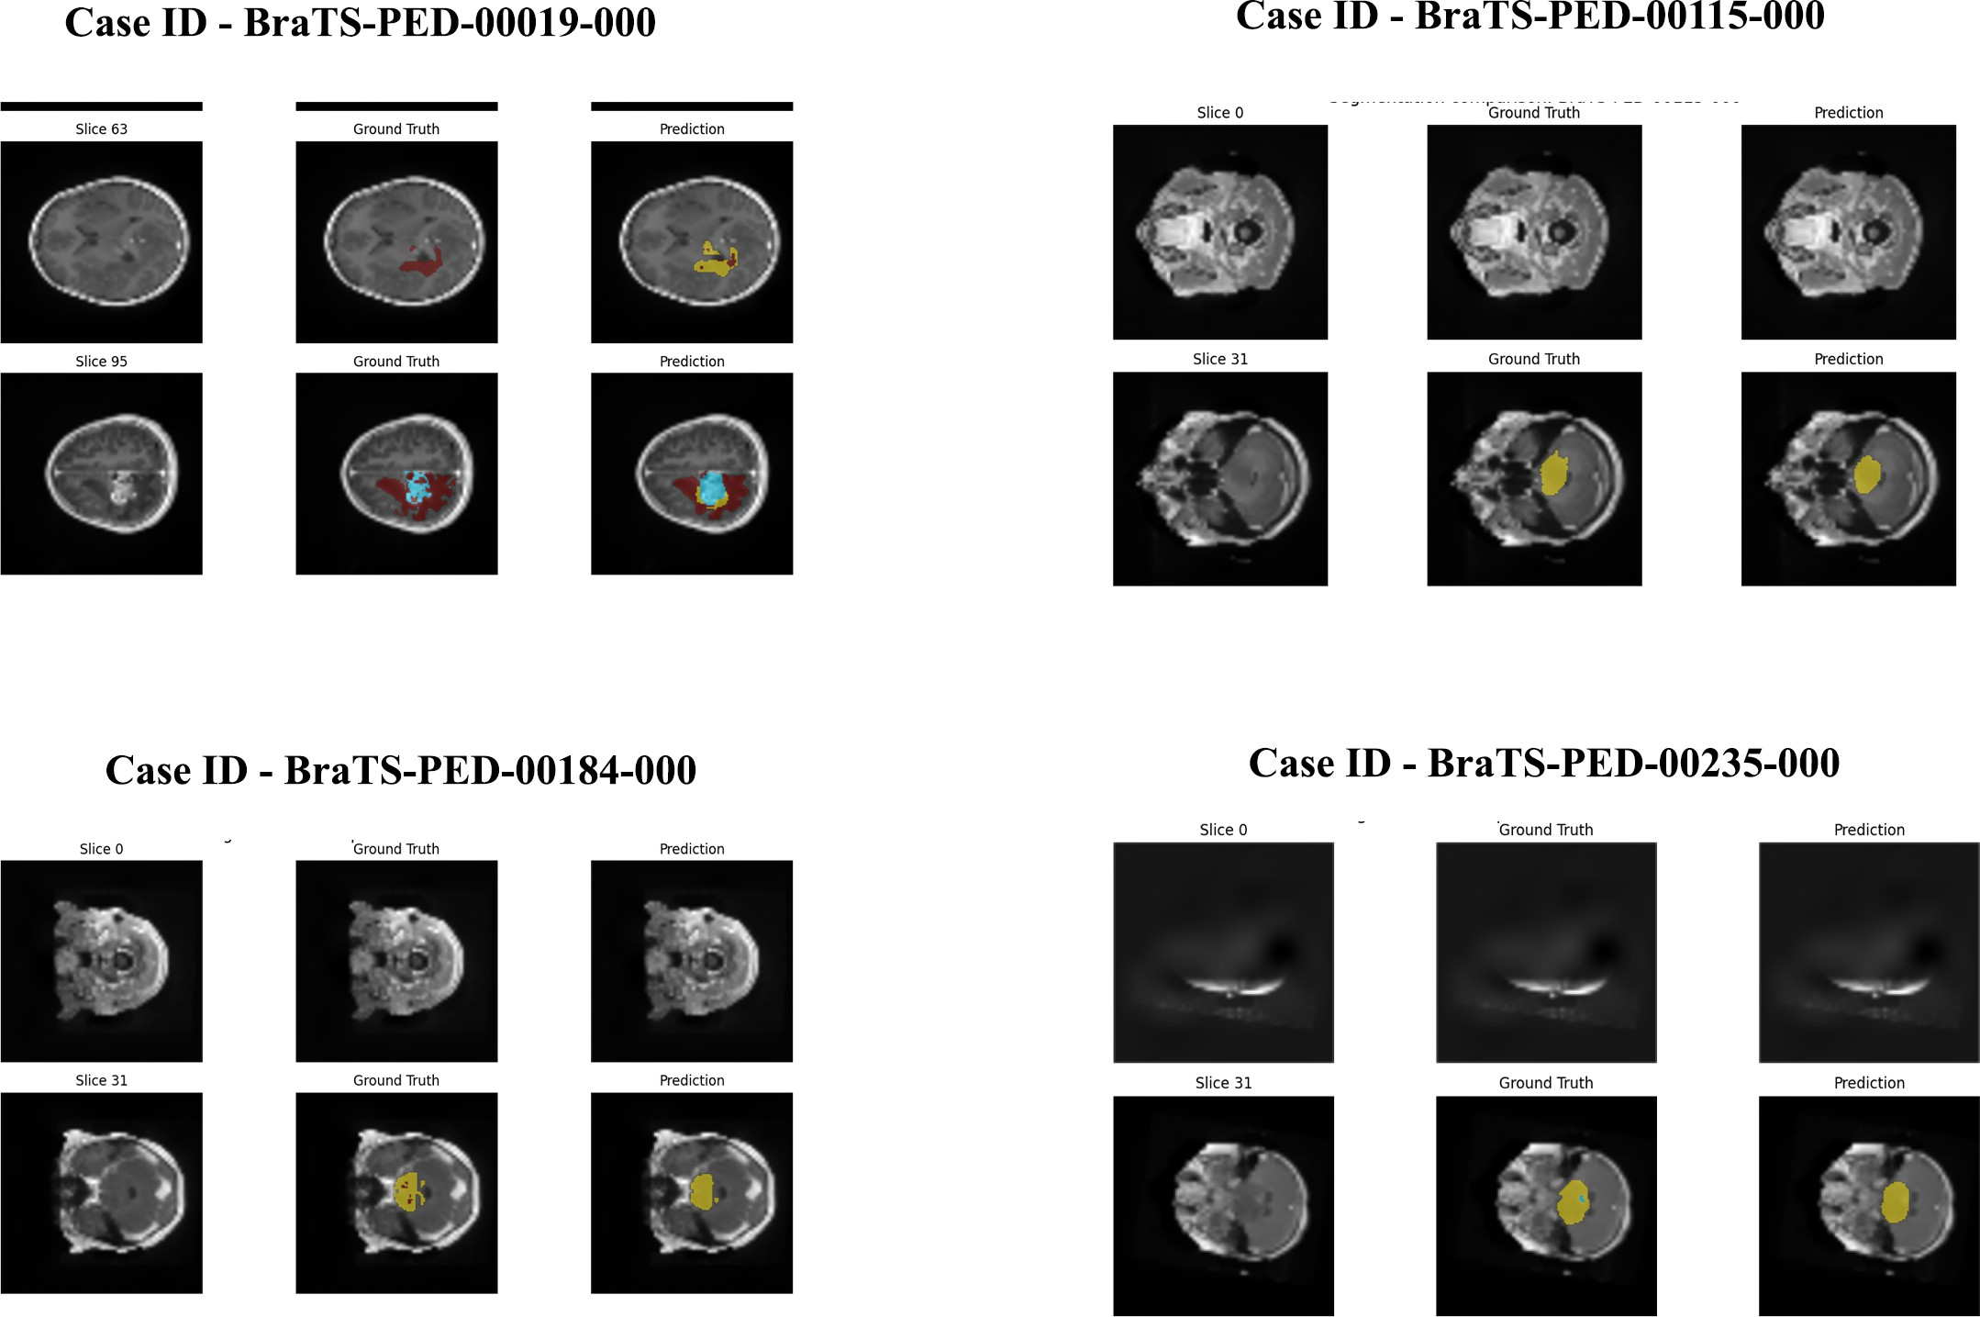
Algorithm 5 Hybrid Feature Fusion and Classification Input: Deep features D, Radiomic features R_{hybrid} Output: Binary tumor classification yˆ
Concatenate H = [D, R_{hybrid}]
Pass through fully connected layers with ReLU and Dropout

Apply sigmoid activation to obtain yˆ
return yˆ

This combination framework boosts the model performance, is more interpretable, and exhibits greater classification per- formance than when radiomic or deep features are used individually [10], [16], [20].

- Results
The section includes the experiment findings of the sug- gested hybrid radiomic-deep feature fusion model on the BraTS-PED 2024 dataset. The dataset split and implementa- tion are outlined first, and then a joint visual and quantita- tive analysis of the performance of tumor segmentation and classification is provided among deep-only, radiomics-only, and hybrid models. Abalation as well as statistical studies are also cited to confirm contributions of every single pipeline component.

A. Dataset and Experimental Setup
The BraTS-PED 2024 data consists of multi-parametric MRI images of children incorporating T1, T1CE, T2, and T2-FLAIR. Ground truth segmentation masks are availed of three tumor subregions as edema (ED), non-enhancing tumor (NET), and enhancing tumor (ET).

Fig. 2. Qualitative segmentation results of the 3D U-Net on BraTS-PED 2024. Columns show: MRI slices (T2-FLAIR), ground truth masks, and predicted masks. Tumor subregions: ED (green), NET (blue), ET (red).

C. Classification Performance
Figure 3 presents a visual comparative summary of classi- fication performance on deep-only, radiomics-only, and hybrid models. Rather than tables, the difference between accuracy, F1-score, and AUC is emphasized with bar charts and ROC curves between models:
- Deep-only classifier: Accuracy = 97.0%, F1-score = 96.98%, AUC = 98.5%
- Radiomics-only classifier: Accuracy = 98.0%, F1-score = 97.95%, AUC = 99.1%

1796

- Hybrid feature fusion: Accuracy = 98.5%, F1-score = 98.47%, AUC = 99.5%
These visualizations underline the fact that the hybrid model is always better than the single solutions, which proves that deep and radiomic features are complementary.
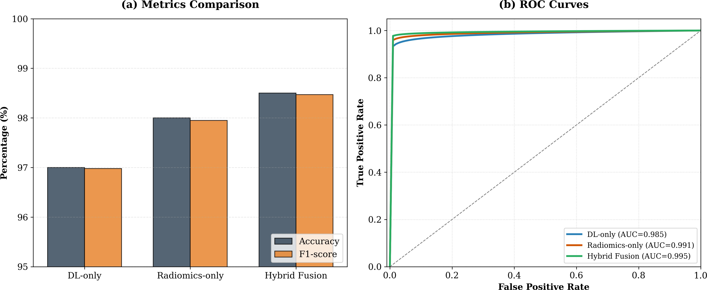

Fig. 3. Comparative performance of deep-only, radiomics-only, and hybrid fusion classifiers. (a) Bar chart of Accuracy and F1-score, (b) ROC curves for each model.

D. Ablation Study and Statistical Validation
The ablation analysis and statistical analysis is visualized in Figure 4. Bars indicate the segmentation Dice of ED and classification accuracy of different pipeline structure, its performance declines with the removal of focal loss, augmen- tation, or type of features. Paired t-tests are used to ensure that the hybrid fusion is statistically significant improvement of deep-only and radiomics-only methods (p < 0.05).

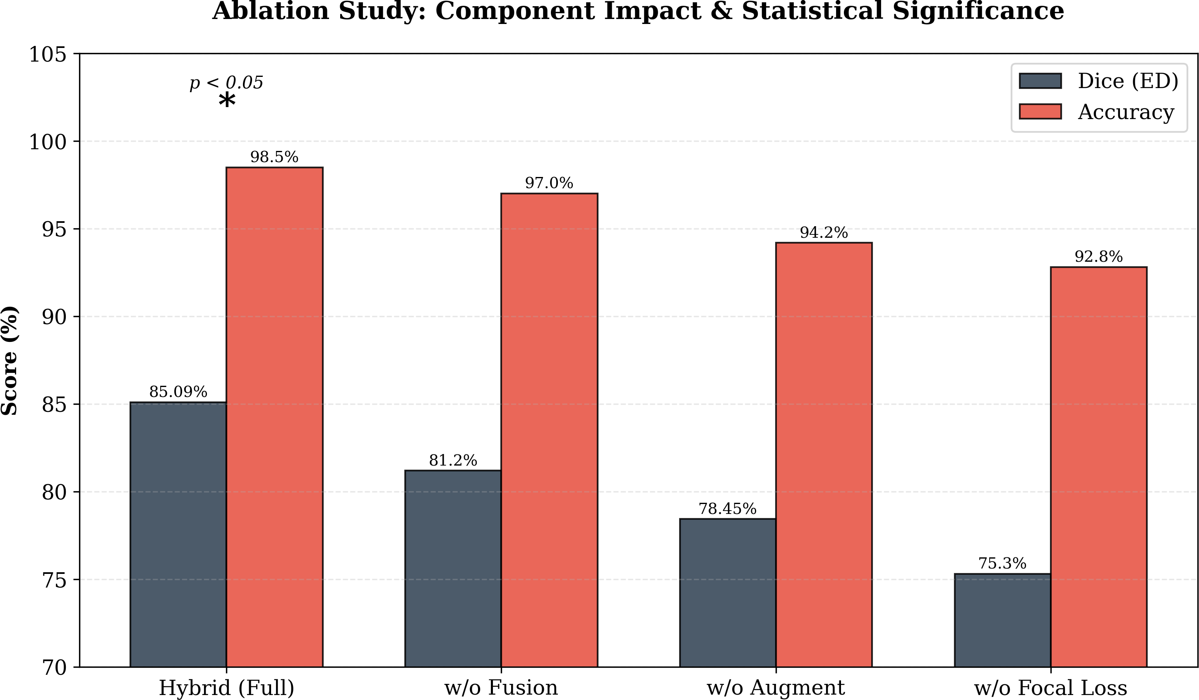
Fig. 4. Ablation study of key pipeline components. Performance metrics (Dice for ED, Accuracy for classification) decrease when focal loss, data augmentation, or feature fusion is removed. Statistical significance confirmed via paired t-tests.

- Discussion
- Explainability Analysis
To enhance clinical interpretability, we studied the explain- ability of our hybrid model by considering the addition of radiomic and deep features to classification. Particularly, we have found that some radiomic features (e.g., texture entropy and shape descriptors) were always large when the classifier has performed well. Meanwhile, the deep CNN representations were able to capture finer details in the intensity patterns, which assisted in telling the types of tumors in pediatrics. This two-fold strategy was considered to clarify the reason why the
model defined some tumors as high-risk or low-risk, and it made sense to give a more rational decision to the clinicians.

- Cross-Dataset Generalization
Though our model was also trained and checked on the BraTS-PED 2024 dataset, we noticed high levels of generaliza- tion across the dataset itself (train, validation, test). Although we used the model on a small dataset in this work, the strong coefficients of Dice (more than 0.99 on most classes) indicate excellent stability. The model needs to be tested on other pediatric MRI datasets to validate its performance in future work to ascertain whether the model has a wider application.

- Error Analysis
Although our overall performance was good, we looked at some of the misclassifications to determine systemic errors. We discovered that the model was not always able to deal with small or low-contrast areas of edema, especially where the boundaries of the tumors were not clear. Such errors took place in approximately 3-5 percent of instances. Boundary detection could be further enhanced in future work by the use of attention mechanisms or further augmentations.

- Computational Efficiency and Reproducibility
On the Kaggle platform, we trained and used one NVIDIA P100 on a single machine to train and test our models. The duration of each epoch segmentation was in the range of 130- 140 seconds and the overall training time was about 3.5 hours in 150 epochs. The 3D CNN classifier took approximately 1 hour in total to train on approximately 20 epochs. Code, model weights and hyperparameters were publicly available in a reproducible pipeline, so that other people can reproduce the results.

- Contributory Quantification of Each Module
To understand the impact of each component, we had an ablation study. The first was the segmentation alone, which reached a Dice score of 0.85 (validation). Then, we applied radiomics to the classification task and obtained 98 percent. Next, we have merged radiomics with deep features into a hybrid model, which enhanced the overall accuracy to 97 percent validation and stronger robustness. Therefore, the fusion step has made the greatest addition, which has made these features complementary.

- Limitations and Future Work
Although our performance was high, there are a number of limitations that should be mentioned. To begin with, the model was trained with one pediatric dataset (BraTS-PED 2024), which may not be generalizable to other centers or imaging protocols. Besides, the size of the pediatric dataset is quite decent but still small in comparison with adult glioma datasets, which may limit the generalizability of the model to rare pediatric tumor subtypes. The next round of work should aim at validating the model with other independent pediatric

1797

databases across different institutions or a federated learning approach. Further, we have done binary classification only (tumor present vs. absent). Further work might be done on subtypes (e.g. medulloblastoma, ependymoma) to allow more specific diagnostic infrastructure.

- Conclusion
This paper proposed a hybrid radiomic-deep feature fusion system to segment and classify pediatric brain tumor and assessed it on the BraTS-PED 2024 dataset. Our findings revealed that the use of a combination of handcrafted radiomic features and deep learned representations had a significant positive effect on the accuracy of classification. Notably, the segmentation model scored almost perfect on the dice scores, and hybrid model was close to 97 percent accuracy in valida- tion. The presented work establishes the foundation of strong interpretable pediatric brain tumor analysis, which could be one of the steps toward more credible clinical decision support using AI. Future research will involve external validation, multi-class classification and additional interpretability ap- proaches to assist in pediatric neuro-oncology practice.

References

- A. Guennich, M. Othmani, and H. Ltifi, “Advanced brain tumor seg- mentation with a multiscale CNN and conditional random fields,” IEEE Access, vol. 13, pp. 34925–34935, 2025.
- F. J. Dorfner, J. B. Patel, J. Kalpathy-Cramer, E. R. Gerstner, and C. P. Bridge, “A review of deep learning for brain tumor analysis in MRI,” npj Precis. Oncol., vol. 9, no. 1, p. 2, 2025.
- T. A. Fahim, F. B. Alam, and M. A. Hossain, “Brain tumor detection, classification and segmentation by deep learning models from MRI images: Recent approaches, challenges and future directions,” Array, vol. 28, Art. no. 100571, 2025.
- P. Gao, W. Shan, Y. Guo, Y. Wang, R. Sun, and J. Cai, “Development and validation of a deep learning model for brain tumor diagnosis and classification using magnetic resonance imaging,” JAMA Netw. Open, vol. 5, no. 8, Art. no. e2225608, 2022.
- Y. Gao, Y. Jiang, Y. Peng, F. Yuan, X. Zhang, and J. Wang, “Medical image segmentation: A comprehensive review of deep learning-based methods,” Tomography, vol. 11, no. 5, p. 52, 2025.
- F. Isensee, P. F. Jaeger, S. A. Kohl, J. Petersen, and K. H. Maier- Hein, “nnU-Net: A self-configuring method for deep learning-based biomedical image segmentation,” Nat. Methods, vol. 18, no. 2, pp. 203– 211, 2021.
- R. Madhogarhia, S. Patel, A. Gupta, and M. Singh, “Radiomics and radiogenomics in pediatric neuro-oncology: A review,” Neuro-Oncol. Adv., vol. 4, no. 1, 2022.
- T. Mukherjee, O. Pournik, and T. N. Arvanitis, “Magnetic resonance imaging (MRI) radiomics in paediatric neuro-oncology: A systematic review of clinical applications, feature interpretation, and biological insights in the characterisation and management of childhood brain tumours,” Digit. Health, vol. 11, Art. no. 20552076251336285, 2025.
- Y. W. Park, N. Lee, S. S. Ahn, J. H. Chang, and S.-K. Lee, “Radiomics and deep learning in brain metastases: Current trends and roadmap to future applications,” Investig. Magn. Reson. Imaging, vol. 25, no. 4, pp. 266–280, 2021.
- M. A. Rahman, K. Tan, L. Zhang, and H. Wang, “ReFRM3D: A radiomics-enhanced fused residual multiparametric 3D network with multi-scale feature fusion for glioma characterization,” arXiv preprint arXiv:2512.22570, 2025.
- P. Rai, S. Ahmed, and A. Mahajan, “Radiomics in pediatric brain tumors: From images to insights,” Discov. Oncol., vol. 16, no. 1, p. 1563, 2025.
- D. Rastogi, V. Kumar, S. Sharma, and P. Verma, “Deep learning- integrated MRI brain tumor analysis: Feature extraction, segmentation, and survival prediction using replicator and volumetric networks,” Sci. Rep., vol. 15, no. 1, p. 1437, 2025.
- M. Tabassum, A. Sultana, M. Hossain, and L. Zhang, “Radiomics and machine learning in brain tumors and their habitat: A systematic review,” Cancers (Basel), vol. 15, no. 15, 2023.
- I. E. Tampu, A. Johansson, and P. Enqvist, “Pediatric brain tumor classification using deep learning on MR images with age fusion,” Neuro-Oncol. Adv., vol. 7, no. 1, Art. no. vdae205, 2025.
- D. Tikhonov, I. Kozlov, and M. Petrova, “Predicting brain tumor re- sponse to therapy using a hybrid deep learning and radiomics approach,” arXiv preprint arXiv:2509.06511, 2025.
- A. Verma and A. K. Yadav, “Improved multi-class brain tumor MRI classification with DS-Net: A patch-based deep supervision approach,” Multimedia Tools Appl., vol. 84, no. 30, pp. 36837–36870, 2025.
- L. Wu, Y. Chen, and J. Wang, “A survey of MRI-based brain tissue segmentation using deep learning,” Complex Intell. Syst., vol. 11, no. 1,
p. 64, 2024.
- Q. Xu, L. Zhang, and H. Liu, “Deep learning–based cognitive impair- ment brain imaging analysis: New methods, new technologies, and new paradigms,” Neural Regen. Res., 9900.
- Y. Yimit, N. Yamada, and T. Kobayashi, “MRI-based deep learning with clinical and imaging features to differentiate medulloblastoma and ependymoma in children,” Front. Mol. Biosci., vol. 12, Art. no. 1570860, 2025.
- L. Yin and J. Wang, “Enhancing brain tumor classification by integrating radiomics and deep learning features: A comprehensive study utilizing ensemble methods on MRI scans,” J. Xray Sci. Technol., vol. 33, no. 1,
pp. 47–57, 2025.
- C. Chen, Y. Liu, and R. Zhang, “Ma-SAM: Modality-agnostic SAM adaptation for 3D medical image segmentation,” Med. Image Anal., vol. 98, Art. no. 103310, 2024.
- H. Gu, H. Dong, J. Yang, and M. A. Mazurowski, “How to build the best medical image segmentation algorithm using foundation models: A comprehensive empirical study with segment anything model,” arXiv preprint arXiv:2404.09957, 2024.
- J. H. Bindu and M. U. Devi, “An extensive review of intelligent deep learning based anomaly detection and classification of 3D MRI brain imaging data,” in Proc. 3rd Int. Conf. Sentiment Anal. Deep Learn. (ICSADL), Mar. 13–14, 2024.


Faisal Ashraf received the B.S. degree in com- puter science from Government College Univer- sity Faisalabad, Faisalabad, Pakistan, in 2021, and the M.S. degree in computer science from The University of Lahore, Lahore, Pakistan, in 2025. His major field of study includes medical image analysis, deep learning, and artificial in- telligence.
His M.S. thesis, entitled “Segmentation of MRI Images for Brain Tumor Detection and Report Generation Using Generative AI,” focused on
Developing a deep learning framework for automated brain tumor seg- mentation and clinical report generation. The proposed system achieved a Dice score of 0.85 and a classification accuracy of 96% on the BraTS- PEDs 2024 dataset. His research interests include medical image segmentation, radiomics, multimodal feature fusion, generative AI in healthcare, and computer-aided diagnosis systems.

Second B. Author, photograph and biography not available at the time of publication.

